Installing

Microsoft Server

On a Physical Server

By: Ruben Thomas Y. Reyes III

Date: 10/30/2023

**Hardware Needed:**

**Server (ex. Dell PowerEdge R730)**

**Hardrives / SSD for the Server**

**USB Flash drive 2.0 / 3.0**

**Software Needed:**

**Activation Key for the OS**

**Rufus** **(**to install Microsoft OS)

Microsoft Server OS (ISO)

<https://rufus.ie/en/>

**How To Create a Bootable Flash drive using RUFUS:**

To start off, make sure you have a flash drive around 32gb or bigger since these are the specs for the server. The bigger the storage the better since you will not run into storage problems when installing Microsoft Server.  
  
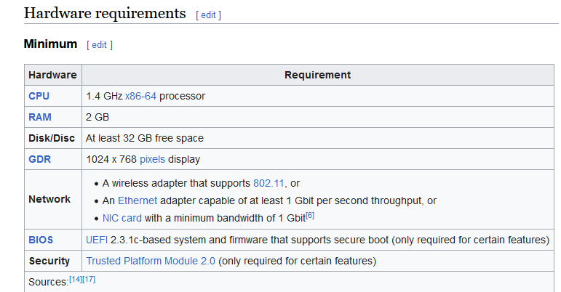

Once you have the required flash drive and MS server operating system. The next step is to create a bootable flash drive using the program “Rufus.” You should have the flash drive and ISO ready on the computer.

After obtaining the required flash drive and ISO. Open the Rufus application and select the flash drive name under the “Device” section.

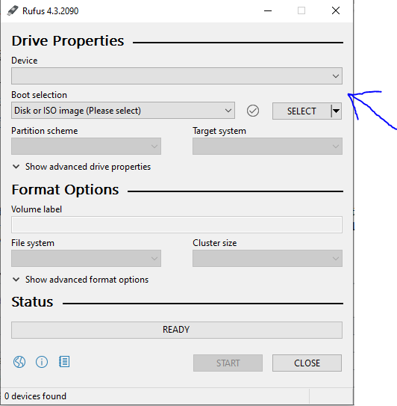

The next step is to choose the ISO for the flash drive. Picked the desired OS (Microsoft Server 2022) and make sure that the file system is Fat 32

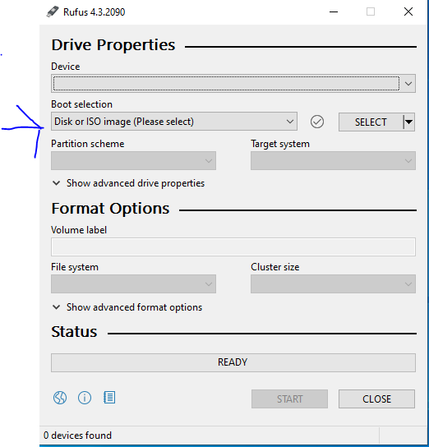

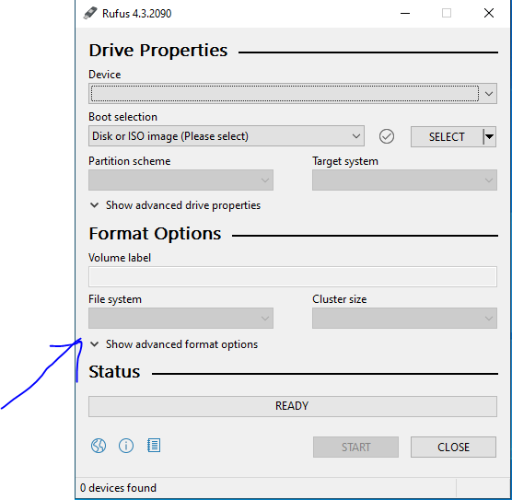

After you have done all the desired configuration. Press “START” and that should create a bootable flash drive for Windows Server 2022.

**Installing MS Server on the Physical Server:**  
  
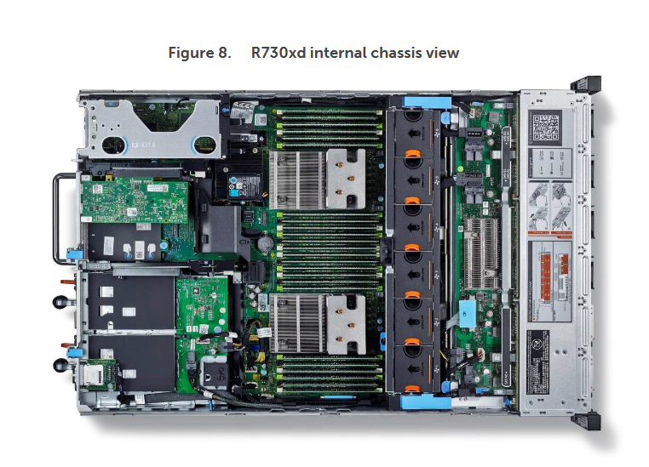

Once you have the bootable flash drive there should be a USB port inside of the physical server where you can connect the flash drive in. This requires you to open the cover of the physical server which is located on top. Once you have connected the flash drive in the USB port of the physical server you can close it and plug in a monitor and a keyboard to go into the bios section of the server.

**Steps in accessing the BIOS menu for the server:**  
  
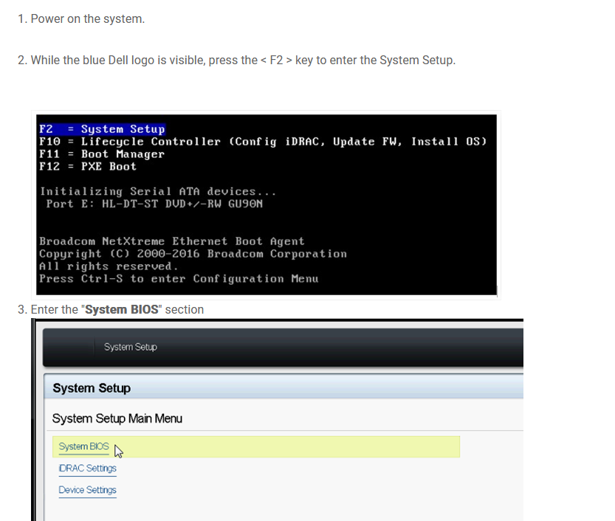

**4.) Go to Boot Settings**

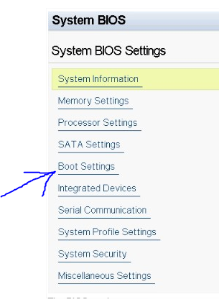

**5.) Go to BIOS Boot Settings**

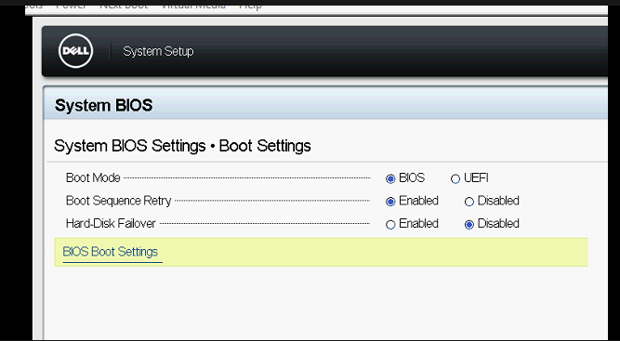

**6.) Only Check the flash drive that has the MS server**

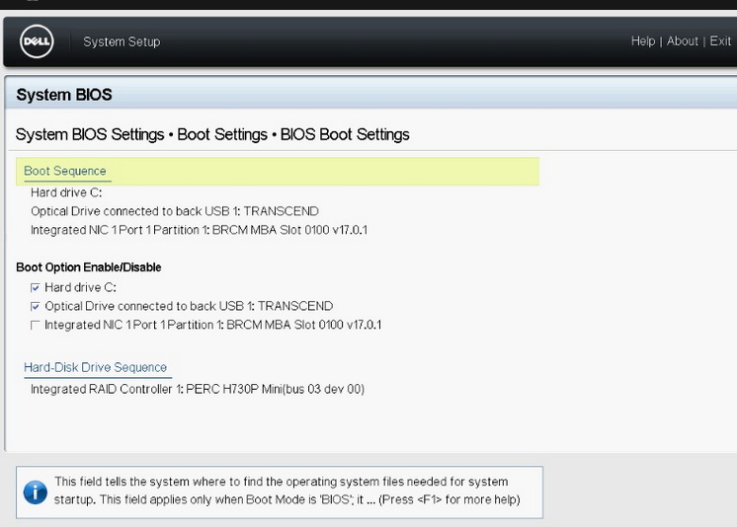

After setting the boot options. You can now restart the server and it will boot up the MS server installation configuration.

**MS SERVER INSTALLATION CONFIGURATION:**

**1.) This should be the screen when booting of the Microsoft server 2022 ISO from the physical server**  
  
 -Make sure to set the right time and language and click **next**

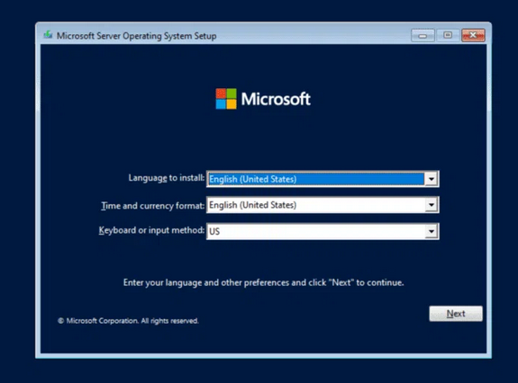

**2.) After clicking next, click** **Install Now**

Note: If they ask for an access code. The professor should provide or give you a link to gain an access code for the OS.

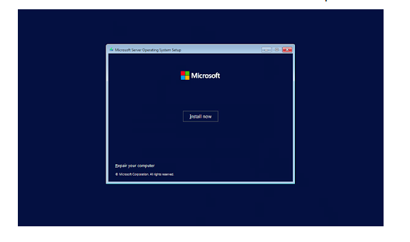

**3.) Choose the standard edition for Microsoft Server Datacenter 2022**

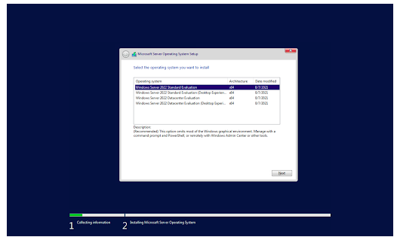

**4.) Pick the desired storage for the operating system and accept the terms and agreement for the installation.**

**Note:** If you have a flash drive that is more than 32gb or 64gb then you can use this as a storage for the OS files, but if you have less than 32gb then you must use another storage. If you do not know what to use, then ask a professor for what storage should be used

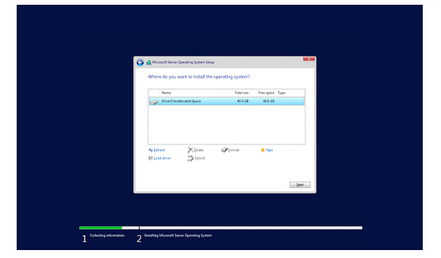

**5.) When choosing the installation make sure to pick the Microsoft Server with GUI**

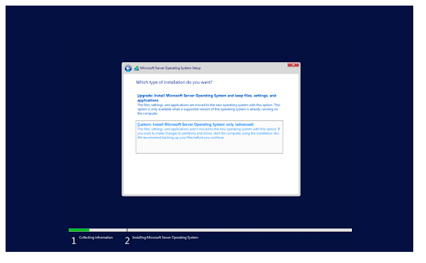

**6.) Wait for the installation to be finished and you have successfully installed Microsoft Server 2022.**

